Conference location: Building D, XJTLU Entrepreneur College, 111 Taicang (太仓) Avenue, Taicang, Suzhou (苏州), Jiangsu Province, 215412, China

Hotel reservation info form and send the reservation to Papers@cyberc.org before October 25, 2023.

Table A. HOTEL RESERVATION INFO FORM
Paper ID (if any) | Guest Name | Check In Date | Check Out Date | Room Type | Email or Cell Phone for contacting
Note:

Please read the following notes before you fill out the form.
- Hotel reservations are NOT mandatory for CyberC 2023 participation. When you contact a hotel to make reservations, please mention that you are attending the CyberC 2023 conference to avail of the preferential pricing. You can also forward a copy to Papers@cyberc.org for our record.
- Please be aware that hotels have limited availability for each room type. To ensure your convenience, it is recommended to make reservations early. Each hotel has its own policy regarding reservations, changes, and cancellations, so please contact the hotel directly for specific details.
- When you arrive at the hotel, please present your reservation form (i.e., Table A) to the hotel receptionist in order to confirm your reservation.
- Reservation and payment for your stay should be made directly with the hotel, not with CyberC. Upon departure, please request a receipt from the hotel for your records. If you send a copy to Paper@cyberc.org, CyberC is only collecting reservation information for statistical and emergency purposes.
Table B. Four Points by Sheraton Taicang
 | English | Chinese | Note
Name | Four Points by Sheraton Taicang | 太仓宝龙福朋喜来登酒店
Contact phone | (+86)18862387121 /Email: EDISON.WANG@FOURPOINTS.COM
Star | Four star
Room Style | Twin Size Room (Include one breakfast) | 舒适双床房(40m², 一份早餐) | RMB 380
 | King Size Room (Include one breakfast) | 舒适大床房(40m², 一份早餐) | RMB 380
Address | No. 288 Shanghai East Road, Taicang, Taicang, China, 215400 | 上海东路288号。距西浦太仓校园约5公里，10分钟车程 | 5 kilometers from the campus. 10 minutes by car.
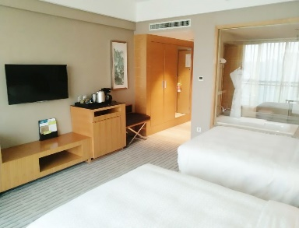
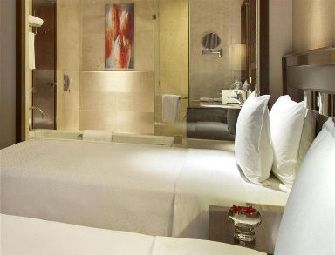
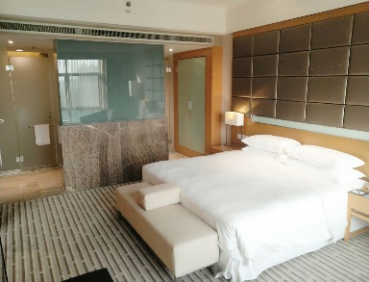
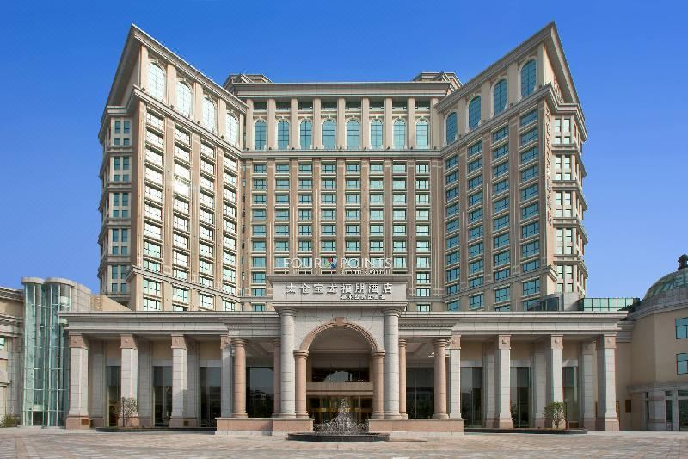
Pictures of Four Points by Sheraton Taicang

